**Using light stable isotopes to assess stream food web ecology in a general ecology laboratory course**

Hannah M. Carrolla,b, Derek D. Houstonc, Suzanne Ankerstjernea, and Alan D. Wanamaker, Jr.a

aDepartment of Geological and Atmospheric Sciences, Iowa State University, Ames, IA, USA; bDepartment of Ecology Evolution and Organismal Biology, Iowa State University, Ames, IA, USA; cDepartment of Natural and Environmental Sciences, Western Colorado University, Gunnison, CO, USA

**Abstract**

Stable isotopes are non-radioactive alternative forms of atoms that are powerful tools used in fields such as archaeology, ecology, forensics, geochemistry, geology, palaeoecology and palaeoclimatology. Stable isotopes are proxy indicators that allow scientists to address a wide-array of research topics ranging from tracking climatic shifts, ascertaining migratory patterns of organisms, matching organisms to their diets and/or environments, assessing food web bioenergetics, documenting ecosystem changes through time, measuring soil carbon budgets and soil microbial activity, etc. Students with no prior experience successfully met learning objectives by completing the requisite field and laboratory protocols, analyzing data, interpreting results, and communicating their findings in a report modeled after a peer-reviewed scientific journal article. While this activity focused on food web ecology in a stream ecosystem, the method is repeatable, cost-effective, and can be modified relatively easily to evaluate food webs in virtually any other ecosystem.

**Keywords**

Active Learning; Biological Education; Community Ecology; δ13C; δ15N; Light Stable Isotopes

**Introduction**

Stable isotopes are alternate forms of atoms that differ in the number of neutrons contained within their nuclei. Stable isotopes maintain the same chemical properties of their elements, but differ in their atomic mass. They are non-radioactive atoms that do not experience radioactive decay (as opposed to radioactive isotopes such as carbon-14/carbon-12 that are commonly used in radiometric dating). Stable isotopes are powerful tools used in many scientific disciplines including community ecology, climate science, fisheries biology, palaeoecology, geology, forensic science, archaeology, soil science, and many others. Stable isotopes are commonly used to track changes in climate (Cerling 1984; Lipp et al. 1991; McDermott 2004; West et al. 2006), ascertain organisms’ migratory patterns (Hobson 1999; Rubenstein et al. 2002; Rubenstein and Hobson 2004), match organisms to their environments (Bearhop et al. 2004; Hogan et al. 2014) or diets (Hilderbrand et al. 1996; Richards et al. 2000; Bearhop et al. 2003; Divine et al. 2017; Patterson et al. 2019), assess food web bioenergetics (Hobson et al. 1994; Vander Zanden et al. 1999; Hershey et al. 2017), document ecosystem changes through time (O’Reilly et al. 2003; Wanamaker et al. 2012; Reynolds et al. 2016; Reynolds et al. 2017), measure soil carbon budgets (Hsieh and Yapp 1999; Bridgham et al. 2006), assess soil microbial activity (Boschker and Middelburg 2002; Steinbeiss et al. 2009), and other topics.

Commonly used stable isotopes include hydrogen (2H/1H), carbon (13C/12C), oxygen (18O/16O), and nitrogen (15N/14N). Researchers can examine isotopic ratios, designated as delta values (δ), to answer questions of interest (Peterson and Fry 1987). For example, δ16O is a measure of 18O and 16O stable isotope ratios, and is commonly used to estimate microenvironmental conditions at the time of sediment deposition (Wanamaker et al. 2007). Another example is the use of δ13C and δ15N to infer animal diets and evaluate ecosystem trophic structure (Hershey et al. 2017). Stable isotopes are measured as a function of the ratio of the more common isotope to the less common isotope, relative to the same ratio measured in a global standard. This value is multiplied by 1,000, and the results are reported in parts per thousand (permil; ‰).

Using carbon from a plant as an example, researchers would place a sample in an elemental analyzer along with a sample of the global standard for carbon, Vienna Pee Dee Belemnite (VDPB). The elemental analyzer combusts the sample, and a mass spectrometer counts the number of atoms of the rare isotope (13C) as well as the number or atoms of the common isotope (12C) in the plant’s tissues. The instruments then repeat the measurements on the VDPB standard. Those counts then allow researchers to calculate the isotopic signature from those counts. Organic carbon is almost always isotopically negative. For example, the tissues of plants range from a δ13C of -10‰ to -24‰, depending on the kind of plant (C3, C4, or CAM) and its environment. This is because plants preferentially use the lighter isotope of carbon, which is the most common in nature (more than 98% of the global carbon pool). The negative value simply shows that there is less of the heavier (rare) isotope relative to the lighter (common) one in the plant’s tissues when compared to the standard. This property whereby one isotope of an element is used more frequently than another is called fractionation, and can be utilized to understand food web ecology.

Organisms within an ecosystem are often grouped into trophic levels that are descriptive of how they attain their energy. Producers (or autotrophs) comprise the lowest trophic level of a system and convert light (or chemical) energy into usable forms of chemical energy (e.g., sugars). Consumers (heterotrophs) are organisms that gain energy by consuming producers, and can be classified as primary consumers (herbivores, planktivores), secondary consumers (carnivores), tertiary consumers (sometimes carnivores, sometimes omnivores), and apex predators that feed on primary, secondary, and tertiary consumers if there is enough energy in the system to support that many trophic levels. A general rule of thumb is that approximately 10% of the energy at one trophic level is incorporated into biomass at the next highest trophic level, although that varies from system to system (Molles and Sher 2019).

Freshwater ecosystems can be slightly different in terms of energy flow because some materials from the terrestrial environment are incorporated as allochthonous material (e.g., dead leaves, fallen branches), otherwise described as course particulate organic matter (CPOM). Organisms called shredders (e.g., crane flies, some caddisflies, some stoneflies, some midges) consume CPOM (Cummins and Klug 1979; Cummins et al. 1989), so there is a large detritus-based component of many freshwater stream food webs. Shredders convert CPOM into fine particulate organic matter (FPOM) that may be consumed by downstream collectors (e.g., some caddisflies, some beetles, some dipterans, some midges). Physical breakdown of CPOM and leaching some solutes can also result in dissolved organic matter (DOM) that can be consumed by zooplankton (e.g., diatoms, water fleas). Freshwater ecosystems also contain autochthonous material (e.g., microbes, plankton, algae, aquatic plants) that originate within the system. Scrapers (e.g., some snails, some caddisflies, some fish) and grazers (e.g., mayflies, some beetles, some snails, suckers) often consume these materials. Of course, there are secondary consumers, tertiary consumers and apex predators within these systems as well (e.g., dragonflies, some midges, insectivorous fishes, piscivorous fishes, birds of prey [such as eagles, cranes, and osprey], and some mammals). A hypothetical stream food web is diagrammed in Figure 1.

In this exercise, we engaged biology undergraduate students in an active learning experience using stable isotopes to evaluate river food web ecology in a Colorado tailwater fishery. The activity centers on the premise that δ13C and δ15N can be quantified and are useful in evaluating organismal trophic positions. The approach was successfully implemented in an upper division ecology laboratory course at Western Colorado University, and trained students to be proficient in the use of stable isotopes, increased their understanding of aquatic ecology, enhanced their data management and analytical skills, and refined their scientific communication skills. While this activity was conducted in the southern Rocky Mountains of Colorado, it can easily be adapted to other ecosystems proximal to other institutions.

**Student Learning Outcomes (SLOs)**

Students will:

1. demonstrate proficiency in sampling aquatic organisms using different techniques including drift nets, kick nets, angling, and plankton tows (optional).
2. classify aquatic organisms to biological order (e.g., Amphipoda, Annelida, Ephemeroptera, Plecoptera) or family (e.g., Chironomidae, Salmonidae).
3. designate the trophic level for sampled aquatic organisms (e.g., producers, primary consumers, secondary consumers, tertiary consumers, apex predators, detritus).
4. demonstrate safe laboratory practices (wearing appropriate personal protective equipment while washing samples under a fume hood), and avoiding cross-contamination of samples while preparing them for submission.
5. analyze data in the open-source statistical software program R, reassess *a priori* assumptions, and draw conclusions based on the data.
6. communicate their findings in a scientific report modeled after a peer-reviewed journal article that includes background literature, the outcomes of statistical analyses, and graphical representations of the data.

Optional (could be assessed via a pre-laboratory worksheet, but were not in this exercise):

1. define common terminology used in stream ecology: allochtonous/autochthonous material; course particulate organic matter (CPOM)/fine particulate organic matter (FPOM)/dissolved organic matter (DOM); shredders/collectors/grazers/scrapers.
2. define common terminology used in stable isotopes analyses: delta values, permil, fractionation, elemental analyzer, mass spectrometry.

In this laboratory exercise, we reconfirmed the applicability of stable isotopes to stream food web ecology as a learning tool. Our approach was as follows: (1) sample aquatic organisms using a variety of techniques, (2) use safe laboratory techniques to wash and prepare samples for analysis, (3) analyze stable isotope data using open-source statistical software, (4) reassess *a priori* trophic level designations and draw conclusions.

**Procedures**

***Site Selection***

Aquatic organisms were sampled from the catch-and-release area on the Taylor River (Figure 2), just below Taylor Park Reservoir, approximately 14 miles northeast of Almont, CO, USA. This site was chosen because (1) it is a tailwater fishery with a relatively constant water temperature and is accessible year-round (we conducted sampling in February when most other water bodies in the area were frozen over), (2) it is not a highly productive ecosystem, so is relatively depauperate and capturing a high proportion of its biodiversity was likely, (3) it is in close proximity (~31 miles) to Western Colorado University campus where students engaging in the exercise were enrolled, (4) it is a popular sport fishery that many Western Colorado University students are familiar with and excited to learn more about.

***Field Sampling***

Because we sought to collect organisms from several trophic levels, we employed an array of sampling methods (SLO1). These are outlined as follows:

*Angling*

A self-selected group of five students with their own fishing equipment and valid Colorado fishing licenses attempted to catch trout (the presumed apex predator of the system) using artificial flies and lures. If successful, they were instructed to take a small fin clip, which grows back, then immediately release the fish back into the river. Students were instructed to use forceps to handle fin clips so as not to risk contaminating the sample with oils from their fingers, then to place the fin clip into an appropriately labeled plastic bag.

*Macroinvertebrate sampling*

The remaining students worked in teams to set three drift nets downstream of the sampling area, where they were left to collect materials carried by the current for the duration of the sampling activity (~ 1 hour). Once the drift nets were set, pairs of students sampled aquatic macroinvertebrates using kick nets. The technique for sampling with kick nets is fairly simple: students were instructed to place the net perpendicular to the flow of the river, then kick along the bottom of the river so that rocks overturned and the current carried any dislodged macroinvertebrates into the net. This activity was conducted for 30 seconds per sampling unit, after which the sample was transferred from the kick net to a sorting tray. Macroinvertebrates, algae and detritus were sorted according to taxonomic group (e.g., Plecoptera, Ephemeroptera, Chironomidae; SLO2), then removed using forceps and placed into individually labeled plastic bags. Each pair of students repeated these steps three times, but organisms were pooled (within student working groups) by their taxonomy (i.e., each group pooled all their stoneflies into one bag, all their mayflies into another, algae into a third, detritus into a fourth, and so on). When kick net sampling was completed, drift nets were checked and samples were collected from them and sorted in the same manner. Samples collected from kick nets and drift nets were kept separate. All plastic bags containing biological samples were packed in snow to keep samples cold during transport back to the laboratory. Upon return to the institution, samples were frozen at -20°C for one week, after which they were thawed and further sorted (see *Laboratory Techniques* below). Cold storage of samples is only necessary if they will not be washed and processed within the same laboratory period.

*Plankton sampling (optional)*

The sun set and temperatures dropped too quickly to sample using plankton tows while in the field in February, but this method could easily be added to the exercise at different times of year, or even by assigning a subset of students to conduct plankton tows instead of sampling with kick nets. Groups of 2-3 students could conduct oblique plankton tows wherein a plankton tow net is pulled through the water at the same depth for a known distance (Figure 3) to be able to calculate the total volume of the water sampled. Once the tow is complete, students use a wash bottle to wash any plankton that is clinging to the sides of the net into the collection jar. These samples need to be sorted in the laboratory under a dissecting microscope.

***Laboratory Techniques***

*Sorting*

Samples were already sorted by trophic level as best as students could ascertain in the field (see *Macroinvertebrate Sampling* above). However, it was critically important for the success of the exercise for them to refine sample identifications to ensure that samples were isolated from those of other trophic levels. This required students to pick through samples under a dissecting microscope and make accurate identifications (SLO2) and preliminary trophic level designations (SLO3). Prior to sorting, students were instructed to don gloves and were reminded of the importance of not touching the samples bare-handed so as not to contaminate them with oils from their skin.

Students used plastic forceps and weigh boats (again, taking care not to touch either bare-handed) to sort samples into the following categories: detritus (sticks, leaves, etc.), algae, midges, mayflies, stoneflies, amphipod crustaceans, fish fin clips. Each sample was then assigned a unique identification code that included a group number, a tentative trophic level, and a sample number (SLO4; Table 1). Weigh boats used in sorting, and glass Petri dishes used for washing (see below) were labeled accordingly using a permanent marker.

Prior conversations with an aquatic ecologist familiar with the system (Dr. Kevin Alexander, Western Colorado University, personal communication with DDH) divulged that the sampling area was relatively depauperate. Therefore, taxonomic identifications were able to be very broad. For example, stoneflies can be categorized as predators, shredders, collectors, and grazers in various areas, depending on the species that occupy those areas, but in this system all stoneflies were likely to be grazers.

*Washing*

Samples were placed into labelled glass Petri dishes according to biological classification/presumed trophic level. Students donned gloves and safety goggles, then transferred Petri dishes containing samples to a fume hood where they were repeatedly washed with a 2:1 chloroform:methanol solution, taking care to keep track of sample IDs during the process (SLO4).

The washing procedure was as follows: (1) Students transferred 10 mL of the 2:1 chloroform:methanol solution into a labelled Petri dish containing a sample using a glass transfer pipette. (2) Using metal tweezers that had been pre-washed with the solution (the wash solution would have melted plastic tweezers and Petri dishes, hence the need to use metal and glass, respectively), students gently agitated the samples for 30 seconds to remove lipids and other surface contaminants (e.g., dirt, pollen) according to previously published methods (Wassenaar and Hobson 1998). (3) Students then transferred the dirty wash solution to a glass waste container in the fume hood using the same glass transfer pipette, and then discarded the dirty pipette into an appropriately labelled broken glass waste container. (4) Using clean glass transfer pipettes for each subsequent wash, students washed the samples twice more, agitating the sample for 30 seconds each time.

*Drying*

All samples were left to dry in the Petri dishes under the fume hood (a dust free environment) for three days. Once dry, the instructor transferred the samples to a low-temperature drying oven, where they were incubated for 48 hours at 50-60°C (anywhere from 24-48 hours should suffice). Dried samples were then transferred by the instructor to 1-dram glass vials, sealed, labelled, and shipped to the Stable Isotope Paleo Environments Research Group (SIPERG) Laboratory at Iowa State University for further processing. Some samples were pooled at the instructor’s discretion, after checking students’ taxonomic identifications, to ensure that adequate amounts of samples (0.5-1.0 g of dried tissue) were submitted as well as to reduce costs (see Table 1).

*Iowa State University SIPERG Laboratory*

Once received, samples were placed into tin capsules and immediately sealed. Carbon (δ13C ) and nitrogen (δ15N ) stable isotopes analyses were conducted on a Costech Elemental Analyzer attached to a Finnigan MAT Delta Plus XL mass spectrometer in continuous flow mode. δ13C was corrected to a VPDB standard, and δ15N was corrected to an air standard. Corrections were made using a regression method, and results reported in permil (‰). Percent concentration (%) was calculated using the peak intensity of the sample.

***Data Analyses***

Statistical analyses and graphing were conducted in R v3.2.2 (R Core Team 2015) using the packages ggplot2 v.2.1.0 (Wickham 2009) and mgcv v.1.8 (Wood 2006). Because these students were naïve to stable isotope analyses, data analyses were kept relatively simple (but a more sophisticated tutorial for more advanced students is included; see supplemental materials). Students were assigned to conduct numerous tasks in an R notebook tutorial (supplemental file X) including loading the data, creating a dual isotopes plot, plotting histograms, assessing distributions, removing outliers, plotting a pairwise Euclidean distance matrix, conducting cluster analyses, and interpreting figures (SLO5). Pairs of students worked through the tutorial together, and turned in completed versions with properly annotated answers to questions that were then graded by the instructor.

When data analyses were completed (the third day of the exercise, on personal computers that were available in the teaching laboratory), students were assigned to write a paper modeled after a peer-reviewed scientific manuscript (SLO6) including an introduction that included background literature, complete methods, a summary of the results (including graphical representations of their data), conclusions, and a literature cited section. Students were instructed to format these according to guidelines for the journal Ecology. This paper was then graded by the instructor.

**Results**

***Sampling and Stable Isotopes***

A general ecology laboratory course with 21 registered students obtained 26 biological samples from the catch-and-release area of the Taylor River below Taylor Park Reservoir, CO, in February, 2019 (Table 1). These biological samples spanned a wide taxonomic breadth, and could be categorized under multiple trophic levels. One sample was omitted from further analysis because it did not meet the minimum size requirements, and others collected by different groups were pooled to ensure minimum size requirements were met as well as to reduce costs. Thus, a total of 19 samples were submitted for stable isotope analyses at ISU’s SIPERG Laboratory, and those results are provided herein (Table 2). In brief, corrected δ13C ranged from -17.5385‰ to -29.5126‰, and corrected δ15N ranged from 8.4066‰ to 49.2551‰ (Table 2).

***Data Analyses***

Students following a well-annotated R notebook tutorial produced several graphical representations of the data. These included dual isotope plots, frequency histograms, distance matrices (Figure 4) and cluster plots (Figure 5). Students were able to manage data, generate graphical representations of their data, and answer questions pertinent to the analytical steps they were taking with high levels of success (Table 3).

***SLO Results***

Student success rates were substantial for each of the student learning outcomes for a general ecology laboratory course with 21 registered undergraduate students (Table 3). While students did not achieve 100% success on all six SLOs, they did on four of the six. For the two SLOs where students achieved <100% success, students attained 92.3% success rates on SLO3, and 82.2% success rates on SLO6 (Table 3).

**Discussion**

***Stable Isotopes Results***

Stable isotopes are useful for assessing organismal trophic levels (Hobson et al. 1994; Vander Zanden et al. 1999; Hershey et al. 2017), and to match organisms to their diets (Hilderbrand et al. 1996; Richards et al. 2000; Bearhop et al. 2003; Divine et al. 2017; Patterson et al. 2019). At the conclusion of this exercise, students were able to reassess the *a priori* assumptions they made while categorizing the biological samples they obtained. While many of the samples were confirmed to have the trophic status they were initially thought to hold, not all were. For example, one group of students caught a leech, which they presumed to be a secondary consumer (based on the common assumption that all leeches are parasites). However, the Euclidean distance matrix they produced revealed the leech’s isotopic signature to be most similar to primary producers rather than to consumers (Figure 4). Moreover, cluster analysis placed the leech in a group with producers, an herbivore, and a detritivore (Figure 5). Hence, the students reassessed their *a priori* assumption and concluded that the leech was likely a free-living non-parasitic species that fed on plant or algal material.

***Assessment***

This exercise focused on student learning over three laboratory periods via a well-organized series of field- and laboratory-based experiential learning exercises wherein students collected biological samples using a variety of methods, applied safe and effective laboratory procedures to process samples, analyzed data, interpreted results, and communicated their findings.

The exercise included six student learning outcomes. SLOs 1-4 allowed students to develop new field- and laboratory-based skills. SLO5 facilitated increased confidence in students pertaining to their ability to manage and analyze data using R statistical software. SLO6 enhanced students’ scientific communication abilities. Performance assessments revealed that success rates for all six SLOs were ≥ 82.2% (Table 3). Therefore, students demonstrated very high levels of learning.

**Educational Impact**

Students were able to function as “real” scientists and were introduced to new field and laboratory techniques, demonstrating proficiency in the required skills to complete the exercise. While this exercise did have six SLOs, the focus was on student learning via the *process* of these field and laboratory activities. This exercise provided a quality educational experience that connected students to their environment in a unique way, two important components of experiential learning (Kolb 1984; Katula and Threnhauser 1999; Kolb and Kolb 2005). Moreover, the exercise raised the students’ ecological consciousness, which may translate into improved societal ecological and environmental understanding (Hill et al. 2004). In addition to students performing well and achieving high levels of success on the six SLOs, at the conclusion of the exercise, several students communicated verbally with the instructor that it was their favorite exercise of the semester.

**Disclosure Statement**

No potential conflict of interest was reported by the authors.

Jardine et al. 2005 – variability in isotopic signatures of different tissues in fish

Figure 1. A graphical representation of a generic aquatic food web depicting energy flow across multiple trophic levels (modified after Merritt and Cummins 1996). 

Figure 2. Students sampling aquatic organisms from the catch-and-release section of the Taylor River, CO. Top left: Students receiving instruction (from DDH) on how to deploy drift nets. Top right and bottom left: Groups of students picking through kick net samples and sorting organisms by taxonomic group and/or presumed trophic level. Bottom right: Students pulling drift nets to conclude the sampling exercise.

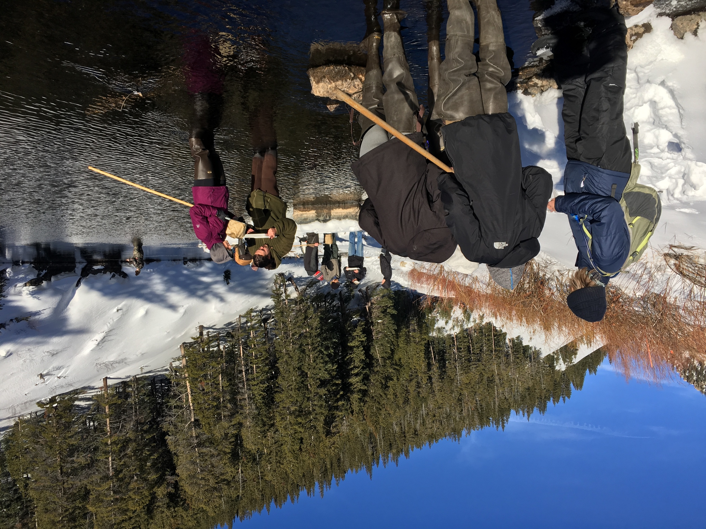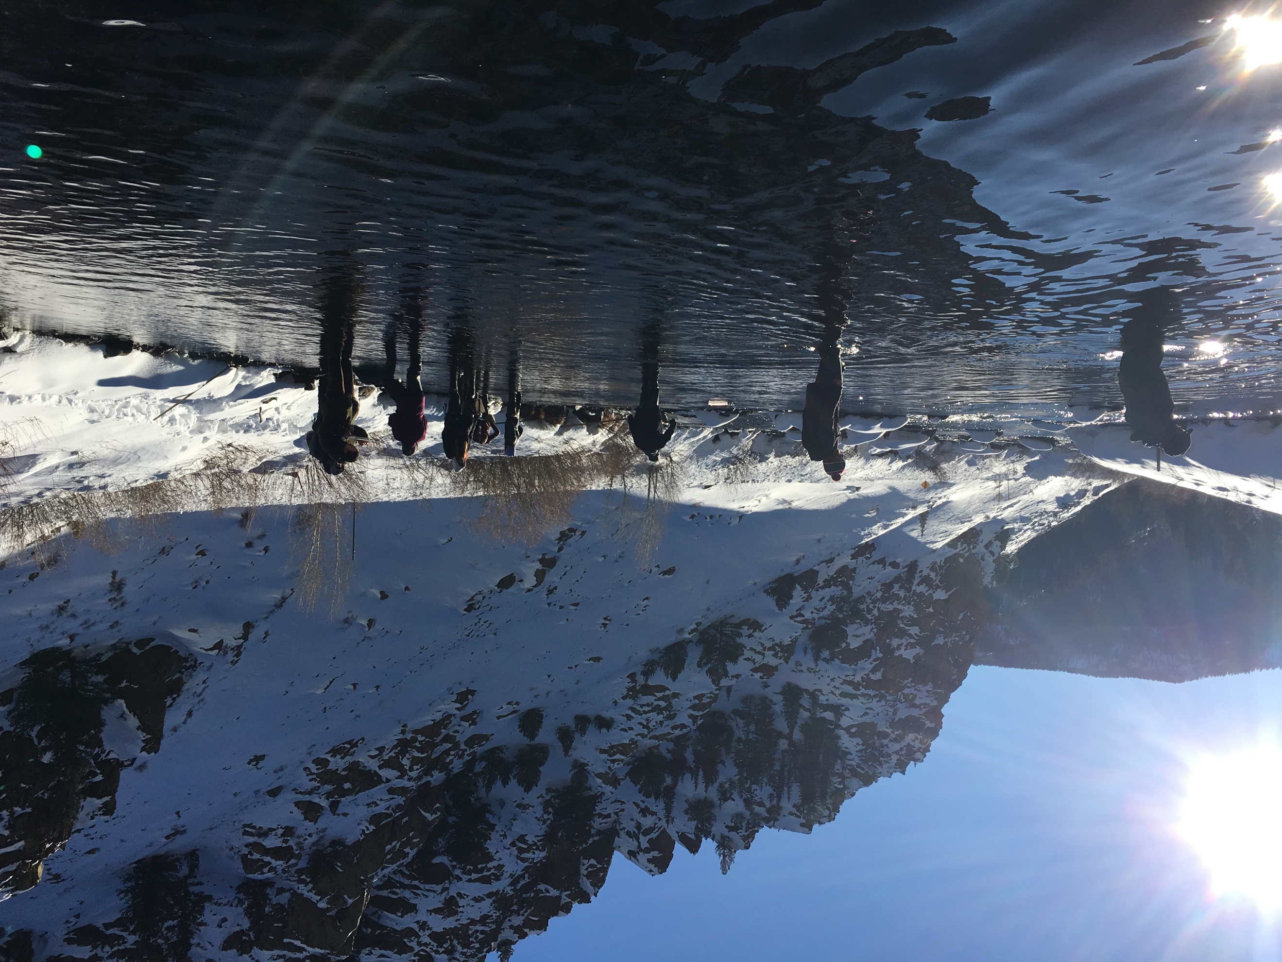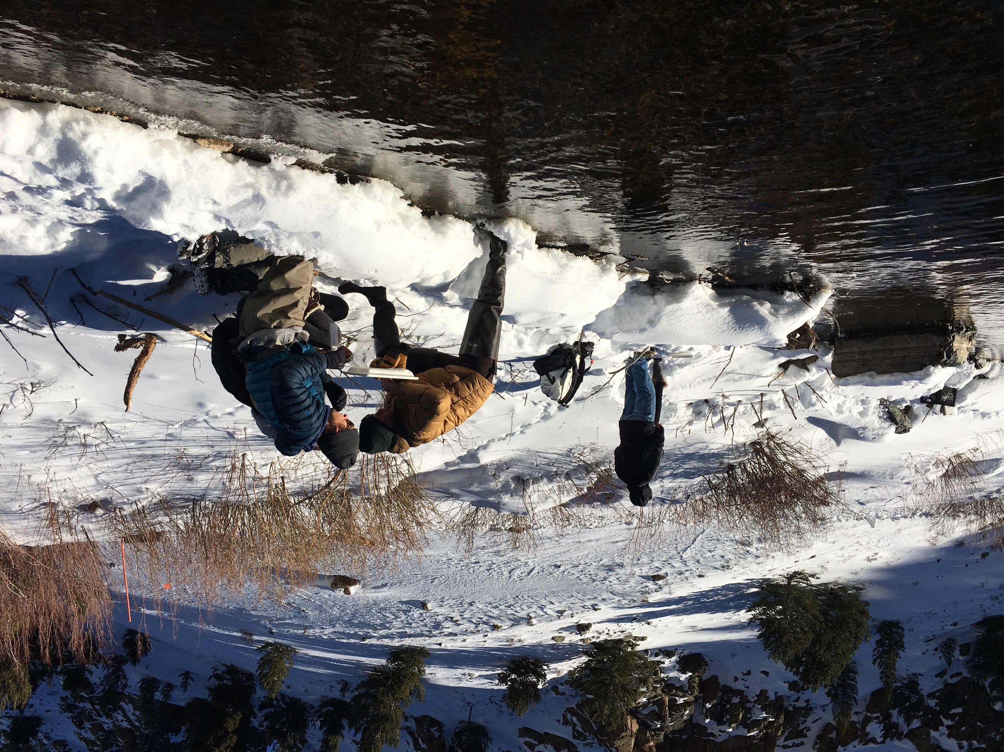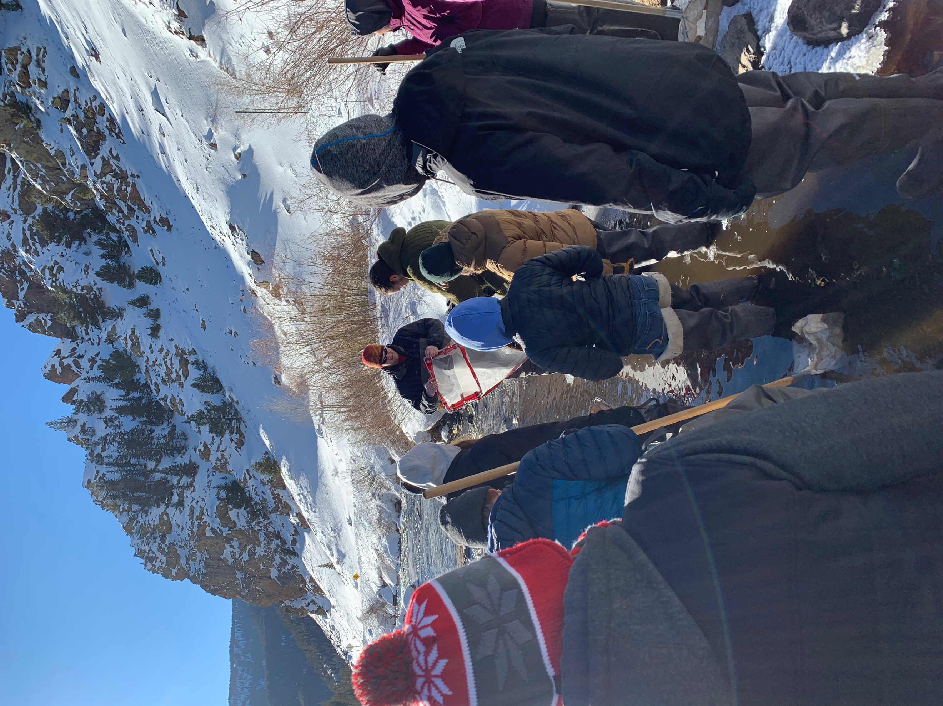

Figure 3. Depiction of an oblique plankton tow



Figure 4. Student example of a pairwise Euclidean distance matrix comparing various trophic categories. Color coding ranges from blue (completely similar) to dark orange (highly dissimilar). Students received instruction on how to interpret these pairwise differences, then were assigned to reassess their preliminary trophic level designations.



Figure 5. Student example of a cluster plot grouping samples together based on corrected δ13C and δ15N values. Students were instructed to produce numerous plots, using different numbers of clusters, then select the number of clusters they felt best represented the data and explain why in the R notebook tutorial and in their laboratory report.



Table 1. Biological samples students acquired from the catch-and-release area of the Taylor River, below Taylor Park Reservoir, CO. Samples were assigned a taxonomic classification, categorized by trophic level, and assigned a unique sample identification number.

|  |  |  |  |  |  |
| --- | --- | --- | --- | --- | --- |
| Sample # | Group # | Presumed Trophic Level (by Students) | Biological Classification | Sample ID | Common Name |
| 1 | 1 | Secondary consumer | Annelida | G1PAANS1 | Leech |
| 2 | 1 | Grazer | Amphipoda | G1GRAMS2 | Scud1 |
| 3 | 1 | Grazer | Plecoptera | G1GRPLS3 | Stonefly |
| 4 | 1 | Grazer | Ephemeroptera | G1GREPS4 | Mayfly |
| 5 | 1 | Collector | Chironomidae | G1COCHS5 | Midge2 |
| 6 | 1 | Detritus | Unidentified Plant | G1DEDES6 | Twig |
| 7 | 2 | Detritus | Unidentified Plant | G2DEDES1 | Twig |
| 8 | 2 | Grazer | Chironomidae | G2GRCHS2 | Midge |
| 9 | 2 | Grazer | Amphipoda | G2GRAMS3 | Scud1 |
| 10 | 2 | Grazer | Ephemeroptera | G2GREPS4 | Mayfly |
| 11 | 2 | Grazer | Plecoptera | G2GRPLS5 | Stonefly |
| 12 | 2 | Producer | Algae | G2PRALS6 | Algae3 |
| 13 | 3 | Shredder | Plecoptera | G3SHPLS1 | Stonefly |
| 14 | 3 | Collector | Chironomidae | G3COCHS2 | Midge4 |
| 15 | 3 | Shredder | Ephemeroptera | G3SHEPS3 | Mayfly |
| 16 | 3 | Producer | Algae | G3PRALS4 | Algae |
| 17 | 3 | Detritivore | Amphipoda | G3DEAMS5 | Scud1 |
| 18 | 3 | Apex Predator | Salmonidae | G3APSAS6 | Brown Trout |
| 19 | 4 | Producer | Algae | G4PRALS1 | Algae3 |
| 20 | 4 | Grazer | Ephemeroptera | G4GREPS2 | Mayfly5 |
| 21 | 4 | Detritus | Unidentified Plant | G4DEDES3 | Twig6 |
| 22 | 4 | Grazer | Chironomidae | G4GRCHS4 | Midge4 |
| 23 | 5 | Detritus | Unidentified Plant | G5DEDES1 | Twig6 |
| 24 | 5 | Producer | Algae | G5PRALS2 | Algae |
| 25 | 5 | Shredder | Trichoptera | G5SHTRS3 | Caddisfly |
| 26 | 5 | Grazer | Chironomidae | G5GRCHS4 | Midge5 |

1 Amphipod samples that were pooled by the instructor after drying to ensure that the minimum quantity requirement was met

2 Sample included a single midge that did not meet the minimum size requirements, but also appeared to be a different species from other samples, so this sample was omitted from further analysis

3 Algal samples that were pooled by the instructor after drying to ensure that the minimum quantity requirement was met

4 Midge samples that were pooled by the instructor after drying to ensure that the minimum quantity requirement was met

5 Misidentified samples – these samples were the same species of stonefly, not midges, and were pooled by the instructor after drying

6 Detritus samples that were pooled by the instructor after drying to ensure that the minimum quantity requirement was met

Table 2. Corrected δ13C (VPDB) and δ15N (air) values for 19 biological samples collected by students for this laboratory exercise. δ13C values are negative as a result of fractionation. Percent concentrations of C and N, taxonomic identifiers, and presumed trophic levels are also provided.

|  |  |  |  |  |  |  |
| --- | --- | --- | --- | --- | --- | --- |
| Sample ID | Identifier | Trophic Level | δ13C | δ15N | %C | %N |
| G1PAANS1 | Leech | Secondary Consumer | -23.0996 | 8.4066 | 40.30 | 9.19 |
| G1GRAMS2, G2GRAMS3,  G3DEAMS5 pooled | Amphipods | Detritivore | -19.3656 | 8.8039 | 40.25 | 8.10 |
| G1GRPLS3 | Stoneflies | Herbivore/Detritivore | -26.5808 | 9.4175 | 50.19 | 10.32 |
| G1GREPS4 | Mayflies | Herbivore | -24.3762 | 8.0686 | 48.65 | 10.43 |
| G1DEDES6 | Wood | Detritus | -18.8707 | 19.8014 | 49.35 | 0.92 |
| G4DEDES3, G5DEDES1 pooled | Wood | Detritus | -23.1492 | 10.4616 | 44.40 | 1.83 |
| G5PRALS2 | Algae | Primary Producer | -24.3774 | 9.0614 | 22.42 | 3.05 |
| G5SHTRS3 | Caddis | Detritivore | -29.5126 | 8.3965 | 47.34 | 9.08 |
| G4GREPS2, G5GRCHS4 pooled | Stoneflies | Herbivore/Detritivore | -27.2451 | 8.8833 | 48.78 | 10.10 |
| G2DEDES1 | Wood | Detritus | -17.5385 | 49.2551 | 50.21 | 0.18 |
| G2GRCHS2 | Midges | Detritivore | -26.0133 | 8.5001 | 49.56 | 9.67 |
| G2GREPS4 | Mayflies | Herbivore | -26.2009 | 7.4077 | 45.50 | 9.20 |
| G2GRPLS5 | Stoneflies | Herbivore/Detritivore | -26.7829 | 10.5149 | 47.04 | 10.78 |
| G2PRALS6, G4PRALS1 pooled | Algae | Primary Producer | -22.5818 | 8.6208 | 21.69 | 2.75 |
| G3COCHS2, G4GRCHS4 pooled | Midge | Detritivore | -25.8693 | 6.9379 | 37.59 | 7.83 |
| G3SHPLS1 | Stoneflies | Herbivore/Detritivore | -27.2536 | 9.6177 | 49.34 | 10.35 |
| G3SHEPS3 | Mayflies | Herbivore | -26.4283 | 7.6753 | 49.37 | 9.75 |
| G3PRALS4 | Algae | Primary Producer | -22.7512 | 8.5011 | 16.44 | 2.22 |
| G3APSAS6 | Trout | Apex Predator | -27.4798 | 11.3337 | 29.98 | 8.89 |

Table 3. Results of student learning outcomes.

|  |  |  |
| --- | --- | --- |
| SLO # | Assessment Method | Success Rate |
| SLO1 | Successful capture of a variety of aquatic organisms by students | 100% |
| SLO2 | Determination of broad taxonomic categories by students, corrected when necessary by the instructor (see Table 1) | 92.3% |
| SLO3 | Tentative assignment of samples to a trophic level by students, with justification to the instructor for why (these were reassessed later in the R tutorial) | 100% |
| SLO4 | Laboratory activities supervised by the instructor and/or teaching assistant | 100% |
| SLO5 | Graded R tutorial with numerous questions answered (including a bonus question; see supplemental file X) | 104% |
| SLO6 | Graded laboratory report modeled after a peer-reviewed scientific article | 82.2% |
| SLO7 | Graded pre-laboratory worksheets covering stream ecology terminology | Not assessed |
| SLO8 | Graded pre-laboratory worksheets covering stable isotopes terminology | Not assessed |